Appendix -3: Facility Numbers

|  |  |  |  |
| --- | --- | --- | --- |
| **#** | **Program Title** | **Submitting Hospital** | **Facility Number** |
| 2 | a) Sarcoma (Chemotherapy)  b) Sarcoma (Pathology)  c) Sarcoma (Prosthesis)* | Hamilton Health Sciences Corporation | 942 |
| University Health Network | 947 |
| The Ottawa Hospital | 958 |
| Sinai Health System | 976 |
| Royal Victoria Regional Health Center | 606 |
| Kingston Health Sciences Centre (KHSC) | 978 |
| Grand River Health Corporation | 930 |
| Windsor Regional Center | 933 |
| Thunder Bay Regional Health Sciences Centre | 935 |
| London Health Sciences | 936 |
| Sunnybrook Health Sciences Centre | 953 |
| Health Sciences North | 959 |

# *facilities in orange do not currently submit for Prosthesis.

# Appendix-11: Valid 2-digits Postal Codes

(Source: Cancer Care Ontario's Data Book - 2012-2013, Appendix B - Province and State codes, at link https://www.cancercare.on.ca/ext/databook/db1213/databook.htm).

The table below provides list of valid 2 digit postal codes for province and State codes.

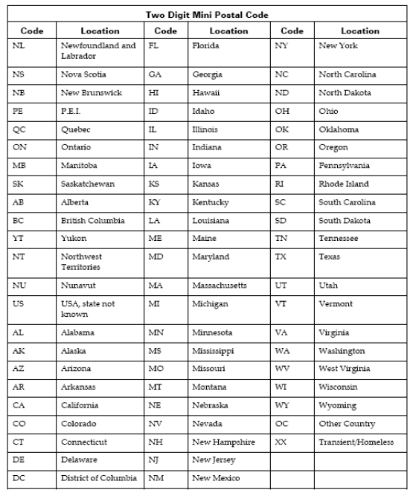

# Appendix-15: Anatomic location

|  |  |
| --- | --- |
|  | **Anatomic location (valid values)** |
|  | Distal femur |
|  | Proximal Femur |
|  | Mid Femur |
|  | Total Femur |
|  | Proximal Tibia |
|  | Total Tibia |
|  | Proximal Humerus |
|  | Distal Humerus and Ulna |
|  | Other |

# Appendix-16: Prosthesis type (valid values)

|  |  |
| --- | --- |
|  | **Prosthesis type (valid values)** |
|  | MRS |
|  | GMRS |
|  | METS |
|  | Kotz |
|  | Other |
|  | N/A |

# Appendix-17: Prosthesis features (valid values)

|  |  |
| --- | --- |
|  | **Prosthesis features (Valid values)** |
|  | Rotating hinge |
|  | Reverse shoulder joint |
|  | Other |

# Appendix-18: Method of Fixation (valid values)

|  |  |
| --- | --- |
|  | **Method of fixation (Valid values)** |
|  | Cemented |
|  | Uncemented |
|  | Other |

# Appendix-19: Procedure type (valid values)

|  |  |
| --- | --- |
|  | **Procedure type (Valid values)** |
|  | Allograft |
|  | Prosthesis |
|  | Other |